A REPORT ON

STUDENT PORTFOLIO

By

Name Of The Student:A SAI SANDEEP

Registration Number: AP22110010636

Prepared in the partial fulfillment of the

Summer Internship Course

# AT

(EDUNET Foundation)



SRM UNIVERSITY, AP

(July, 2024)

# ACKNOWLEDGEMENT

I am honored to present this project on "STUDENT PORTFOLIO" as a key component of my Summer Internship Course at SRM University AP. This project is the culmination of collective efforts, dedication, and the support of many individuals and organizations. I am pleased to take this opportunity to extend my heartfelt gratitude to those who have significantly contributed to the success of this endeavor.

Firstly, I wish to express my deepest appreciation to Sir Prof. Manoj K. Arora, Vice Chancellor of SRM University AP, for offering me the opportunity and the resources necessary to undertake and complete this project. His unwavering support and visionary leadership were pivotal to the success of this project.

I am also profoundly grateful to my Industry Mentors from EDUNET Foundation. Their expert guidance, insightful feedback, and practical advice were instrumental in navigating the complexities of the project and ensuring its successful completion.

My sincere thanks go to my Faculty Mentor, Sir Prof. Ashok Kumar Pradhan, for his constant support, encouragement, and academic insight. His constructive feedback and invaluable suggestions significantly enhanced the quality and rigor of my work.

Lastly, I would like to extend my deepest gratitude to my family and friends for their unwavering support, patience, and encouragement. Their belief in my abilities and their constant encouragement were a source of great inspiration throughout this journey.

Thank you all for your invaluable contributions and support.

.

# ABSTRACT

The development of this Student Portfolio utilized a combination of HTML, CSS, and JavaScript. The project commenced with initial planning and requirements gathering, followed by the creation of wireframes and prototypes. An agile methodology was employed during the development phase, involving iterative cycles of coding, testing, and refinement to ensure optimal results.

**Key Features:**

* **Home Section:** Highlights the user's talents and academic background.
* **About Me Section:** Includes a succinct biography and a resume.
* **Projects Section:** Showcases past projects completed by the user.
* **Contact Me Section:** Provides a channel for direct communication.

The execution phase encompassed rigorous testing for functionality, usability, and accessibility. Enhancements were made based on usability feedback to improve the user experience. Security measures were implemented to protect user data and maintain privacy.

The final product is a polished and visually appealing portfolio that effectively presents the student's skills and achievements. Positive user feedback indicated satisfaction with both the design and functionality, confirming that the portfolio meets the needs of its intended audience.

In summary, the Student Portfolio project demonstrates the successful application of web development technologies to create a valuable tool for students. It enhances their professional image and supports their job search and networking endeavors.

# Table of Contents

1. INTRODUCTION ------------------------------------------------------→ 1

1. OVERVIEW OF THE ORGANIZATION---------------------------→1 TO 3

1. INTERNSHIP PLAN----------------------------------------------------→4 TO 6

1. PROJECT OVERVIEW------------------------------------------------→7 TO 12

1. OUTPUTS & CONCLUSION------------------------------------------→13 TO 16

1. REFERENCES-------------------------------------------------------------→17

**Introduction**

#### Organization’s Business Sector

EDUNET Foundation operates primarily within the Educational Sector.

#### Education Sector in India:

India's education system is pivotal to its socioeconomic growth, characterized by its extensive and intricate framework. It includes a spectrum of public and private institutions, from pre-primary education to advanced university studies.

As of March 4, 2024, India boasts 50,734 colleges, an increase from 45,473 at the end of FY22, and 1,265 universities, up from 1,014 the previous year. In the academic year 2021–22, higher education enrollment reached 43.3 million students, up from 41.3 million in 2020–21, with a balanced distribution between male and female students.

**Key Aspects of the Indian Education Sector:**

India's large student population presents both significant opportunities and challenges for the education sector.

The education system spans multiple levels, including primary, secondary, higher secondary, undergraduate, and postgraduate education.

The sector is undergoing a digital transformation, with increasing technology integration into teaching and learning processes.

Skill development is a major focus, aiming to align educational outcomes with the evolving job market demands.

Challenges persist, including infrastructure limitations, teacher shortages, quality concerns, and access disparities.

The Indian government has introduced several initiatives and policies to improve the quality and reach of education nationwide.

#### 

#### 

#### 

#### Overview of Organization

**2.1 Brief History**

Established in 2015, EDUNET Foundation is a social enterprise in India dedicated to bridging educational and business gaps. The foundation aims to enhance student performance, foster innovation, and create a robust business ecosystem. By focusing on emerging technologies, it supports the expansion and development of knowledge ecosystems and prepares a workforce for Industry 4.0.

**2.2 Business Size**

EDUNET Foundation's annual revenue stands at $39.4 million. Revenue per employee is approximately $112,500.

**2.3 Product Lines**

The foundation provides services to schools, universities, vocational institutions, and municipalities. Since its partnership with SIE in 2021, it has impacted over 200 schools. Its community programs target two main groups: (1) individuals who have exited the formal education system for various reasons, and (2) members of underrepresented social groups. The focus is on building basic digital literacy, future-proof skills, and pathways to further educational opportunities.

#### Competitors

Like all leading enterprises, EDUNET Foundation faces competition from organizations such as Magic Crate, eDC IIT Delhi, ABC for Technology Training, and MIDAS India.

#### Summary

EDUNET Foundation, founded in 2015, is a prominent social enterprise in India dedicated to improving student employability, fostering innovation, and bridging academic and industrial divides. With a workforce of 350 and an annual revenue of $39.4 million, the foundation develops solutions to enhance the information ecosystem. It offers diverse courses aimed at community development, higher education, and vocational training. Notable initiatives include the Vigyan Jyoti program for female STEM students, SkillsBuild with IBM, and Tech Saksham with SAP and Microsoft. These programs have collectively benefited hundreds of thousands of students and educators by advancing digital literacy and future readiness. While competing with institutions like Magic Crate and eDC IIT Delhi, EDUNET Foundation distinguishes itself through extensive partnerships and a strong commitment to its mission.

# INTERNSHIP PLAN

3.1 Introduction

During my virtual internship at EDUNET Foundation, I had the opportunity to work closely with the IBM SkillsBuild program, specifically focusing on Front-End Development. This department is dedicated to bridging the gap between academia and industry by enhancing student employability through innovative educational initiatives and cutting-edge technical solutions.

**3.2 Content**

**Internship Duration**

* **Start Date:** June 3, 2023
* **End Date:** July 28, 2023

**Departments Visited and Duties Performed**

**Week 1: Orientation and Introduction***June 3, 2023 - June 7, 2023*

* Engaged in orientation focusing on enhancing communication skills and understanding the impact of professional conduct.
* Received an overview of the SkillsBuild platform and its educational offerings.
* Explored essential soft skills for career development.
* Gained an introduction to Web Technology, highlighting its significance in modern development.
* Participated in practical sessions to apply concepts learned during the week.

**Week 2: Fundamentals of Web Development***June 8, 2023 - June 14, 2023*

* Introduced to the basics of the Internet and web browsers.
* Covered foundational HTML concepts, including its structure and key elements such as Div, Span, Lists, and Tables.
* Delved into CSS basics, including various types and their applications.
* Engaged in hands-on coding exercises to implement HTML and CSS knowledge.

**Week 3: Advanced HTML and CSS***June 15, 2023 - June 21, 2023*

* Explored advanced CSS topics, including selectors and properties for background, text, links, tables, and lists.
* Gained insight into how computers operate, web development fundamentals, and the role of front-end development.
* Applied advanced HTML and CSS concepts in practical coding sessions.

**Week 4: CSS and Introduction to JavaScript***June 22, 2023 - June 28, 2023*

* Reinforced CSS knowledge through targeted exercises.
* Introduced to JavaScript basics, including its functions and the role of objects and classes.
* Integrated CSS and JavaScript through coding practice to enhance web development skills.

**Week 5: Advanced JavaScript***June 29, 2023 - July 5, 2023*

* Studied JavaScript in relation to the Document Object Model (DOM), browser DOM, and Web APIs.
* Introduced to JSON and jQuery for advanced JavaScript functionality.
* Participated in coding exercises to reinforce understanding of JavaScript concepts.
* Attended a session on Enterprise Design Thinking Practitioner methodologies.
* Applied JavaScript knowledge through additional coding practice.

**Week 6: Final Project and SkillBuild Courses***July 6, 2023 - July 12, 2023*

* Focused on creating interactive web pages using JavaScript as part of a final project.
* Completed a PowerPoint presentation provided by EDUNET and initiated work on the project synopsis.
* Finalized the web development course and job readiness skills course on the IBM SkillBuild platform.

**Week 7: Project Completion and Presentation***July 13, 2023 - July 19, 2023*

* Successfully completed the web development project.
* Expanded knowledge by exploring new topics relevant to web development.
* Prepared and submitted the final project presentation to EDUNET by the deadline of July 25.
* Practiced coding to further improve programming skills.

**Week 8: Report Compilation***July 20, 2023 - July 26, 2023*

* Compiled all project documentation and materials into a comprehensive internship report.
* Drafted and reviewed the report to detail all activities, learnings, and outcomes of the internship experience.

**Project Assigned**

The focus of the Front-End Development project was to develop a Student Portfolio.

### 3.3 Summary

Engaging in the collaborative Front-End Development program between EDUNET Foundation and IBM SkillsBuild has been a profoundly enriching experience. Over the course of eight weeks, I gained in-depth knowledge and practical expertise in web development, spanning from foundational HTML and CSS to advanced JavaScript techniques.

The program's structured weekly progression allowed for a comprehensive learning journey, starting with orientation and essential soft skills, advancing through core web technologies, and culminating in a detailed final project. Each week was thoughtfully designed to balance theoretical insights with hands-on coding practice, ensuring a robust understanding of web development principles and their applications.

### Project Overview

**4.1 Problem Statement**

**Title: Leveraging a Dynamic Portfolio to Enhance Student Visibility and Opportunities**

In the current competitive academic and professional landscape, students often face difficulties in effectively presenting their skills, accomplishments, and projects in a coherent and visually engaging manner. Traditional CVs and resumes frequently fall short in showcasing a student's full range of abilities, leaving potential employers and educational institutions unaware of their true potential.

Our objective is to create a dynamic, user-friendly, and visually appealing platform for student portfolios using HTML, CSS, and JavaScript. This platform will provide students with the means to display their work in a format that is both readable and attractive to academic institutions and prospective employers.

**4.2 Background and Description of Work**

**Background:**

In the digital era, establishing a strong online presence is essential for professionals across all fields. A well-designed portfolio website that highlights projects, achievements, and skills enables potential employers and collaborators to gain a comprehensive understanding of an individual’s capabilities and expertise.

**Description:**

**Objectives:**

The primary goal of the Student Portfolio Project was to develop a personal portfolio website that effectively highlights my front-end development skills and projects. The specific objectives included:

* Demonstrating proficiency in HTML, CSS, and JavaScript.
* Applying web development principles to create an aesthetically pleasing and functional website.
* Showcasing the ability to develop responsive and interactive web pages.
* Providing a platform to present my work to potential employers and collaborators.

**Project Overview:**

The Student Portfolio project aims to deliver an extensive, user-friendly platform for showcasing student portfolios, emphasizing achievements in both extracurricular and academic domains. The platform enables students to present their work in a well-organized and polished manner, including projects, activities, talents, and academic records. Designed with user experience in mind, the platform features a visually appealing and intuitive interface. It comprises four main sections: Home, About Me, Projects, and Contact Me. Each section can be customized to allow students to highlight their individual skills while maintaining control over their content. The website also integrates secure data management and connections with social media and professional networks, enhancing students' visibility and opportunities.

**Context in Project:**

The Student Portfolio was developed using HTML, CSS, and JavaScript and is divided into four key sections:

1. **Home**
2. **About Me**
3. **Projects**
4. **Contact Me**

**Home:**

The Home section serves as the initial page, providing a welcoming introduction and setting the tone for the site. It offers initial navigation to other sections and includes a resume button for quick access to detailed qualifications.

**HTML Structure:**

* **Section Wrapper:** Contains the main container for the Home content.
* **Home Content Container:** Houses elements such as greeting and introduction messages.
* **Greeting:** A warm welcome message to set the tone.
* **Introduction:** Brief overview of the portfolio owner.

**CSS Structure:**

**left-class:**

* margin-top: 20px;
* font-size: 2rem;
* color: #f5deb3; (Wheat)

**leftsection-class:**

* padding-top: 200px;
* height: 500px;
* width: 500px;
* font-size: 2.5rem;
* color: #f0e68c; (Khaki)

**rightsection-class:**

* display: flex;
* width: 500px;
* height: 500px;
* padding-top: 200px;
* background-color: #fff8dc; (Cream)

**Font Styling:**

* **Font Family:** For the Home section, the font used is ('Poppins', sans-serif), which provides a modern and clean appearance.

By refining these CSS styles and incorporating improved design principles, the portfolio will not only present information effectively but also engage users visually and functionally.

### About Me section

**HTML Structure:**

The About Me section provides a brief introduction and overview of the user’s academic background. The section uses the <legend> tag to encapsulate and describe the user's academic records and introductory information. Below this, the user's skills are listed in a visually appealing manner using CSS to achieve a horizontal layout.

**CSS Structure:**

For styling the skills section, we employed ID selectors for precise targeting:

* **#skills:**
  + **Font Size:** Set to 30px for clear readability.
  + **Display:** Set to inline to ensure that the skills are listed horizontally.
* **#skills ul li:**
  + **Display:** Set to inline to align the list items horizontally.
  + **Margin-left:** Set to 2% to provide spacing between list items.
  + **List-style:** Set to circle for a clean and organized bullet point style.

### Projects

**HTML Structure:**

The Projects section displays the user’s projects in a horizontal layout, complete with images representing each project. Each project includes hyperlinks to GitHub repositories, allowing viewers to explore the code and further details.

**CSS Structure:**

* **.p class:**
  + **Display:** Set to flex to align projects horizontally.
  + **Margin-left:** Set to 130px to create space between the projects and the page edges.
* **.Mem class:**
  + **Margin-right:** Set to 100px to ensure adequate spacing between individual project entries.

Contact Me section

**HTML Structure:**

The Contact Me section includes various ways to get in touch with the portfolio owner. It provides:

* The user’s address.
* Mobile number.
* Email address.
* Social media links for easy and direct communication.

**CSS Structure:**

For effective display and organization of contact information, the following CSS classes were used:

* **.contact a img:**
  + **Display:** Set to flex for a professional layout.
  + **Height and Width:** Both set to 40px for uniformity.
  + **Border Radius:** Set to 50% for a rounded, polished look.
* **.address class:**
  + **Text-align:** Centered to align address details neatly in the middle of the section.
* **.bottom class:**
  + **Display:** Set to flex for alignment.
  + **Margin-left:** Set to 40% to position the section appropriately.
* **.icons class:**
  + **Margin-right:** Set to 10% for spacing between social media icons.
  + **Margin-bottom:** Set to 500px to ensure proper separation from other content.

### 

### 

### 4.3 Conclusion

The Student Portfolio Project effectively addresses the challenge of showcasing student skills and achievements by creating an engaging, user-friendly, and visually appealing online platform. Leveraging the capabilities of HTML, CSS, and JavaScript, the project highlights advanced web development techniques and offers a dynamic and customizable space for students to display their academic and extracurricular accomplishments.

Organized into four key sections—Home, About Me, Projects, and Contact Me—the platform ensures a holistic and well-rounded presentation of student information. Each section is meticulously designed to enhance user experience and showcase content effectively. By incorporating integration with social media and professional networks, the portfolio not only boosts the visibility of students but also expands their opportunities for networking and professional growth.

This approach empowers students to present their abilities in a compelling and organized manner, facilitating improved communication with potential employers and academic institutions. As a result, the platform enhances students' prospects for success in an increasingly competitive academic and professional environment.

OUTPUTS&CONCLUSION

## 5.1 Outputs

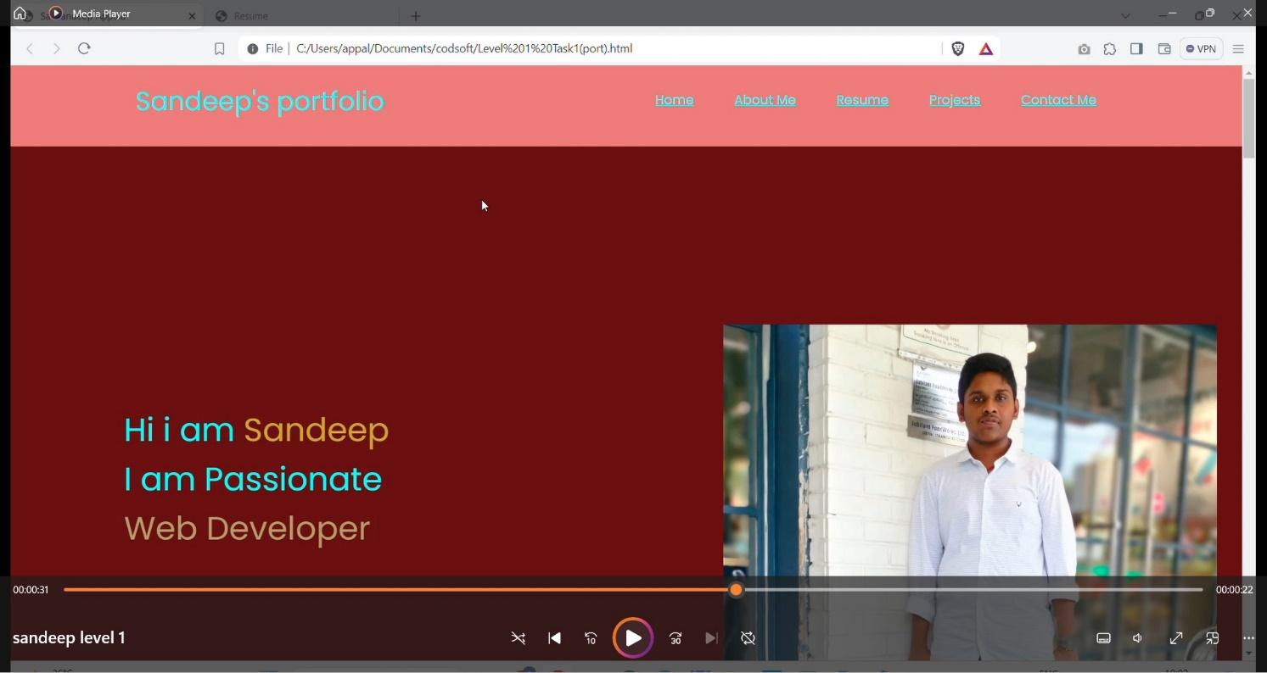

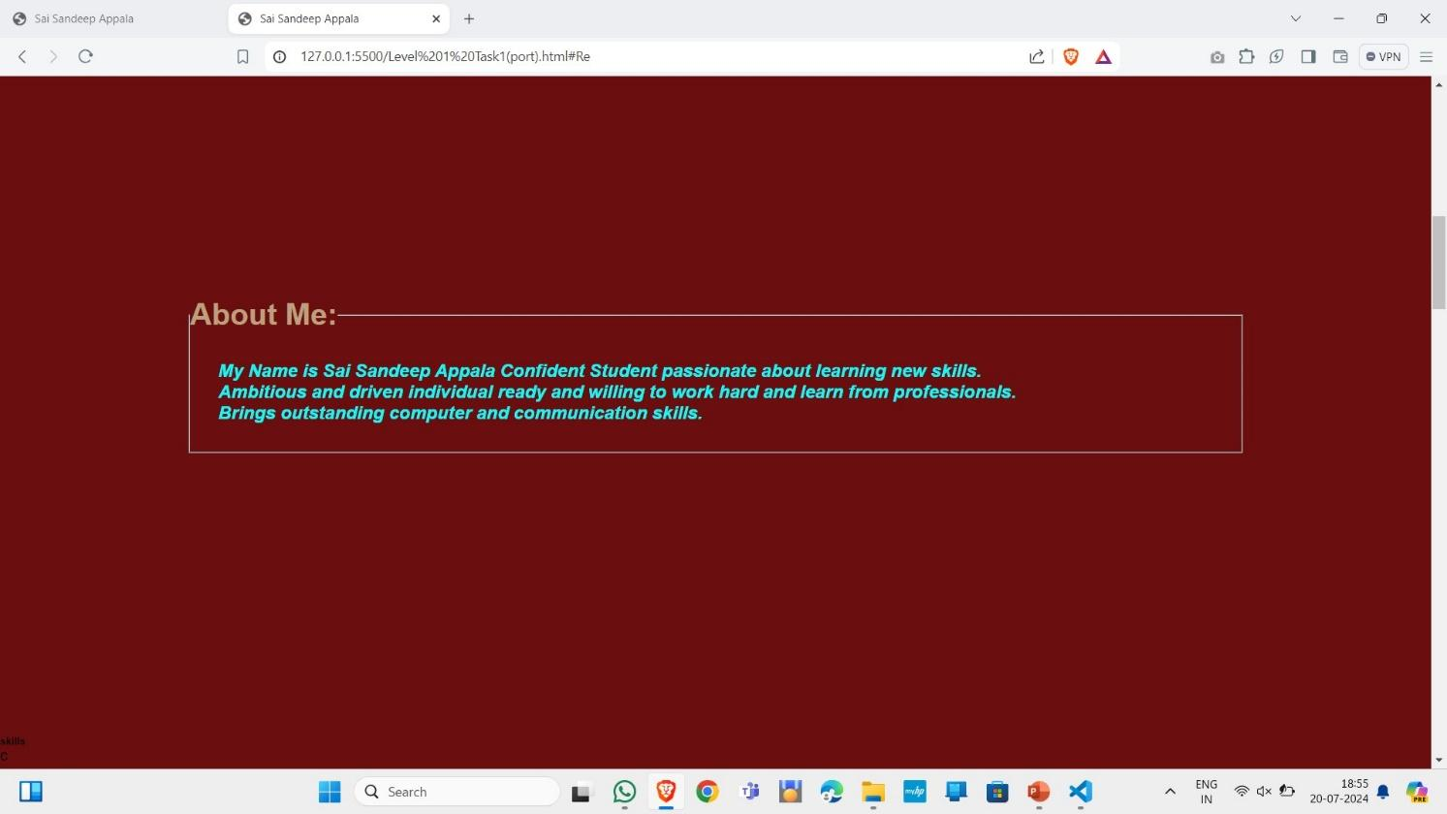

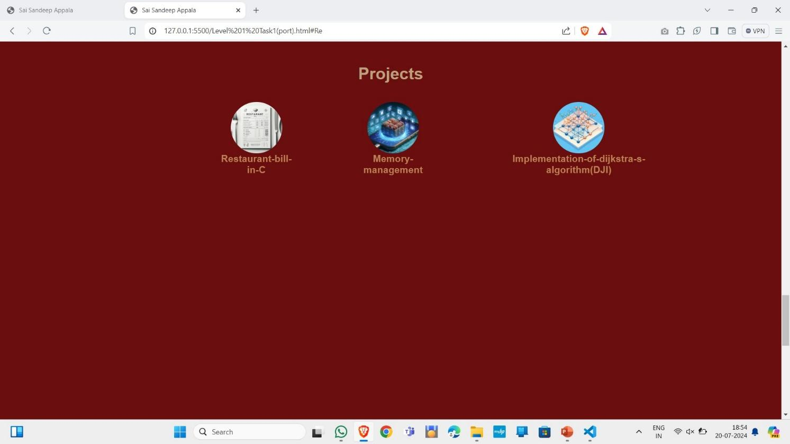

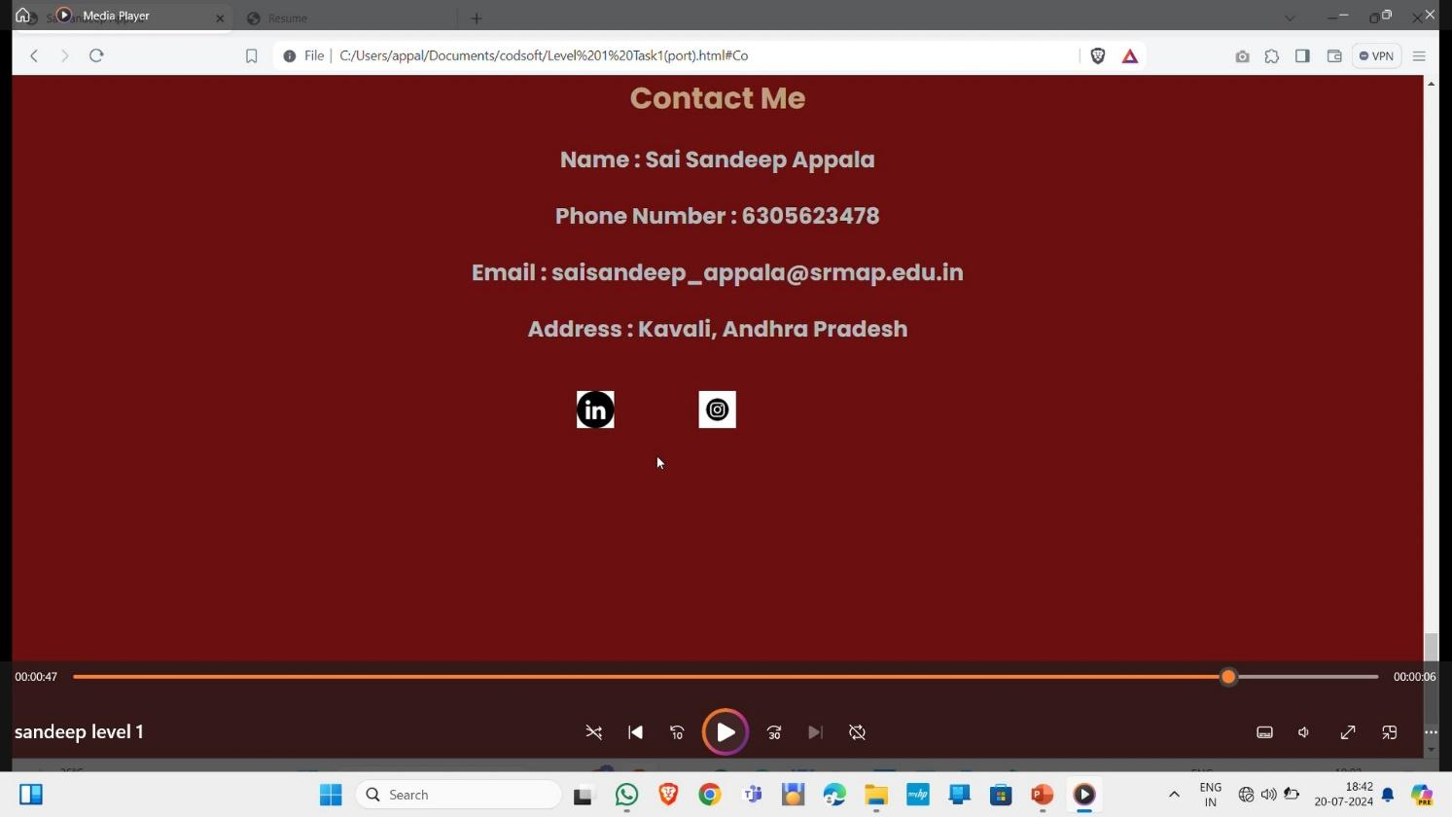

References :

1. https://www.geeksforgeeks.org/front-end-development/
2. https://www.w3schools.com/js/
3. https://create.microsoft.com/en-us
4. https://skills.yourlearning.ibm.com/?_ga=2.247597255.1321776411.17 17390299-317707596.1717390298&lang=en&ngoid=0107&strategy=google

This is the github link of my project and I think there is no need of any read me file

link:<https://github.com/Appalasaisumanth/my-briother>